# Example Requirements Document

*Note: The easiest way to edit your own version of this document is to go the top menu and select ‘File’ and ‘Make a copy’. This will then save a copy of the document to your Google Drive.*

*Alternatively, you can select the ‘Download As’ option.*

This template complements the article about [How to Write a Simple yet Effective Requirements Document](https://www.scalablepath.com/blog/how-to-write-a-simple-yet-effective-requirements-document-and-come-out-with-a-great-product/). This template uses a fictional e-Commerce Website as an example throughout. You can use this template to help create your own requirements document.

## Goals and Context

*Note: This section is used to give wider context to the development team and to ensure everyone is working to the same goal.*

### What is the goal?

Our goal is to create an e-commerce website that brings all the small independent organic skincare brands together.

### What problem does this project solve?

Currently, many organic skincare brands are small and do not have great distribution channels to the customer. By consolidating all these niche and independent brands we will consolidate multiple purchase occasions into just one. Simplifying the process for the end user. While the cost of bringing together so many wholesalers is high, it will be offset by the higher margins on these higher margin products.

### What is the vision?

By consolidating the large but fragmented independent organic skincare market, there is the opportunity to create one brand that stands for the entire industry. This brand would represent the honest and wholesome values to all products on the website. Creating this brand will enable the website to better compete against the larger established skincare wholesalers.

## User Personas

*Note: Three example profiles have been included. Depending on the complexity of your product you may need more. Typically we use at least 3 external users and all key internal users.*

The following are the three key user personas that will use the e-commerce website.

### Young Professional

|  |  |
| --- | --- |
| User Type | Website User (External) |
| Occupation | Personal Assistant |
| Name | Sam Smith |
| Gender | Female |
| Age | 34 |
| Education | College |
| Location | New York, NY |
| Objective | Sam works long hours and no longer has the time to research and buy skincare items. She wants to be able to quickly find her favorite brand and product using the website search feature and order for same day delivery to make sure she never runs out. |

|  |  |
| --- | --- |
| User Type | Website User (External) |
| Name | Lucy Stevens |
| **Occupation** | **Magazine Editor** |
| Gender | Female |
| Age | 45 |
| Education | University |
| Location | New York, NY |
| Objective | Sam is often featured in the media and asked about her cosmetics choices. She wants to be seen as caring about the environment while keeping up with the latest trends. Currently she spends a lot of time searching for new products. She would like to be able to view side by side comparisons of the details of each product to be sure it is certified organic for example. |

### 

|  |  |
| --- | --- |
| User Type | Admin (Internal) |
| Name | Dave Mattheson |
| **Occupation** | **Website Content Manager** |
| Gender | Male |
| Age | 27 |
| Education | University |
| Location | San Francisco |
| Objective | Dave is an employee of the e-commerce website. His role is to write content for the website based on the newest trends and products. He wants to be able to see products as they are ordered and before they go live so he can alter copy and imagery and ensure consistent tone through the website. He also needs to know what products have been ordered to write relevant blog copy ahead of products being listed. |

### Site Admin

## User Stories

*Note: This section list high level and key user stories (often called Epics) that the website must support upon completion of the MVP (first) release. The typical format to use for stories is: As a <type of user>, I want <some goal> so that <some reason>.*

### Website Users

As a Website User, I am busy and have little time to buy skincare products. I want to be able to purchase products quickly and painlessly. Ideally with one click purchasing.

As a Website User, making the correct product choice is vital. I want to see my product options side by side so I can make an educated choice quickly.

### Website Admin

As an Admin, I want to be able to see new products and products categories as they are ordered so I can write content for the website.

As an Admin, I want to be able to track the performance of product titles so that I can see what copy best converts to sales.

## Sitemap

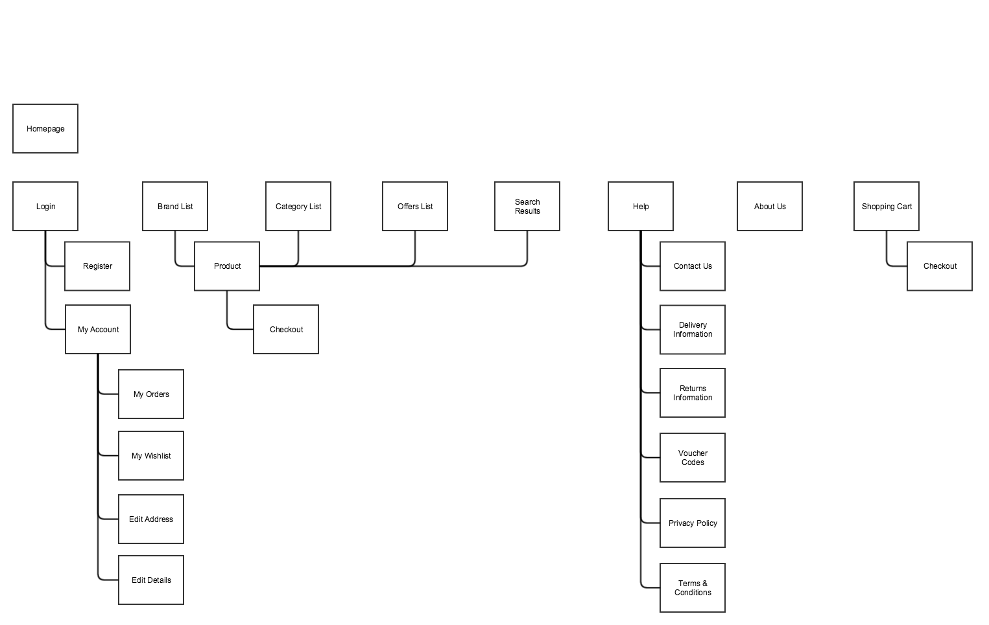

## Page Descriptions

|  |  |
| --- | --- |
| Page | Items |
| Homepage  / | 1. Hero Branding Area 2. Featured Products Section 3. Browse Categories boxes 4. Search form |
| Category Page  /category/:category_name | 1. Featured Category Products 2. Product filters 3. Product list |
| Product Page  /product/:product_id | 1. Product Image 2. Product Title 3. Product Description 4. Add to cart button 5. Sizing Chart 6. Product Specifications 7. Product Reviews |
| Checkout Page  /checkout | 1. List of items in cart 2. Proceed to payment button 3. Ability to change quantities in cart |

## 

## Wireframes

*Note: Below are two examples of wireframes. One is a sketch of the side by side comparison module. Sketches are quick and, if done correctly, are enough for the development team to work with. The other wireframe is of the cart page and was created in Balsamiq, a prototyping tool. While these tools offer more features and consistency they are time-consuming and not always required.*

Wireframe 1a: Pen & Paper Sketch

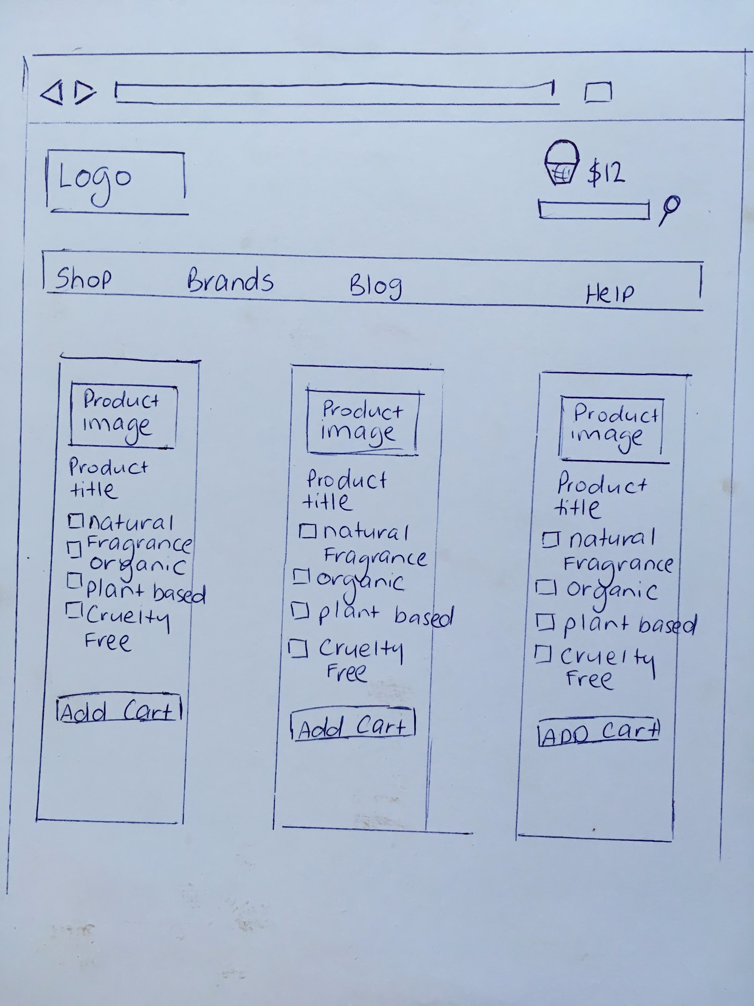

Wireframe 1b: Pen & Paper Sketch

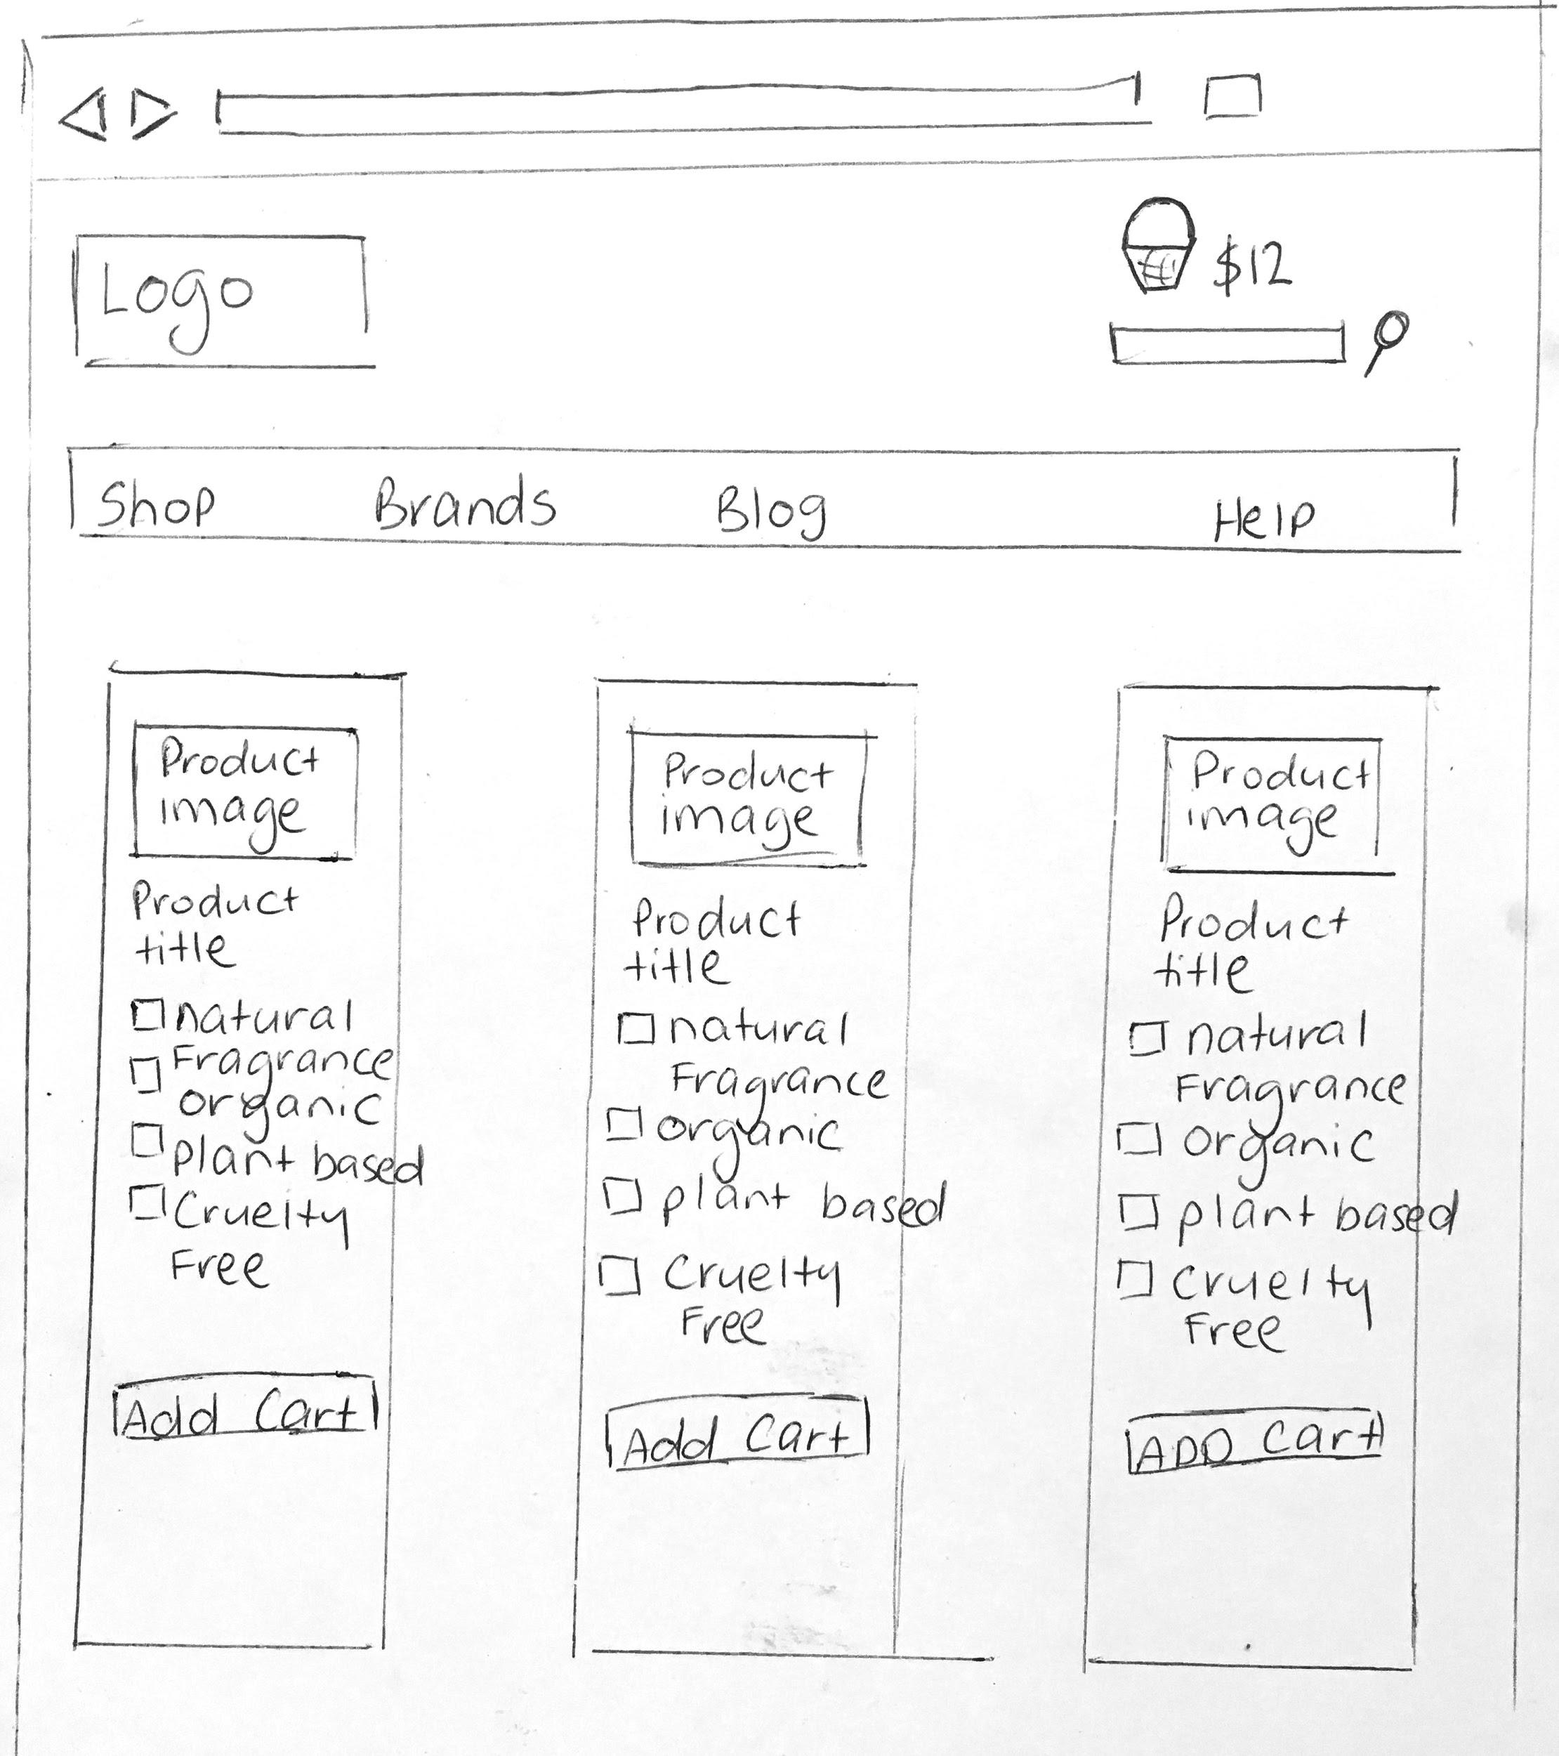

Wireframe 2: Prototype Tool

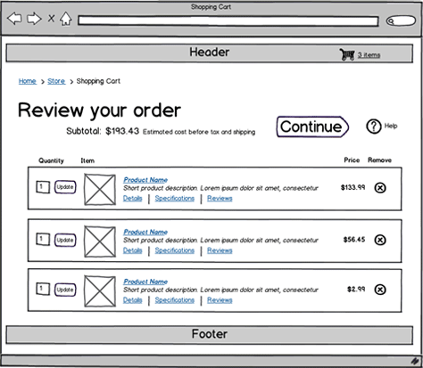

## Non-Functional Requirements

1. The application must be built in Ruby on Rails
2. The application must be hosted on AWS
3. The application must use Stripe for payment processing
4. The application must work in all modern browsers
5. The application must be responsive (work well and look good on all screen sizes)
6. The application must be able to support 1000 simultaneous users

## Risks

1. Our predictive recommendation engine, a key differentiator, may be difficult to code.
2. Our business account may not be approved with Stripe.

## Future Iterations

Note: This section is where you list all features that will not be included in the MVP release, but may be important for design or/and development to keep in mind.

|  |  |
| --- | --- |
| **Feature** | **Description** |
| Shopper Alerts | A feature that will email users when a product that was out of stock that they viewed is back in stock. |
| Wish List | The ability for a user to save an item to their wish list. |
| Mailchimp Integration | When a user creates an account automatically add them to our mailing list using the Mailchimp API. |

# 